# **CTF Topic: Introduction To LAN**

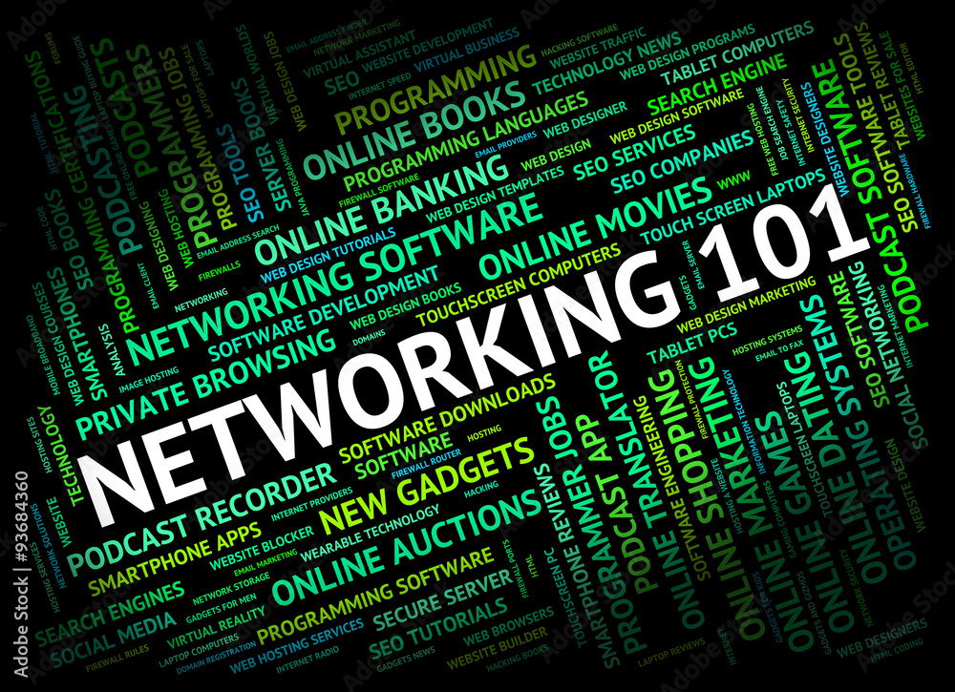

# **Introduction**

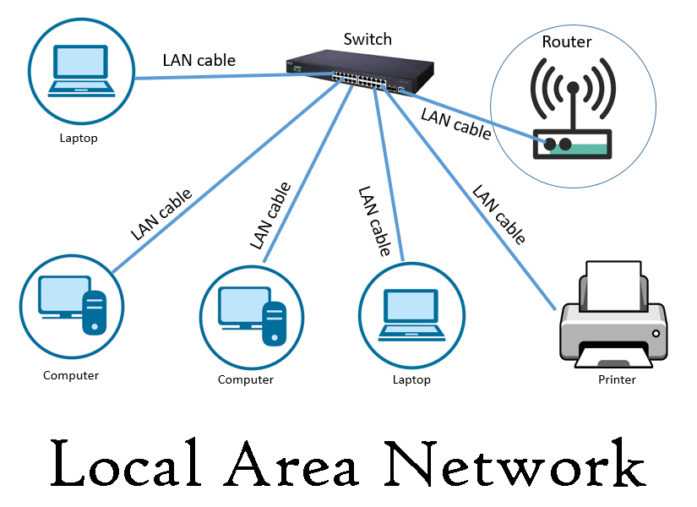

A Local Area Network (LAN) is a network that interconnects devices within a limited geographical area, such as a home, office, or campus. It facilitates the sharing of resources, such as files, printers, and internet connections, among multiple devices including computers, smartphones, and other network-enabled devices.

# **Type of Lan**

There are several types of LANs based on their configuration and architecture:

**1. Wired LAN**: Uses physical cables (Ethernet) to connect devices. Known for reliability and high speed.

**2. Wireless LAN (WLAN)**: Uses wireless communication (Wi-Fi) to connect devices. Provides mobility and ease of installation.

**3. Virtual LAN (VLAN)**: Uses software to segment a single physical network into multiple logical networks. Enhances security and efficiency by separating different groups of devices.

# **Why Lan is Important**



**1. Resource Sharing**: Allows multiple devices to share resources such as printers, storage, and internet connections.

**2. Communication**: Enables fast and efficient communication between connected devices.

**3. Cost Efficiency**: Reduces the need for duplicate equipment and services by sharing resources.

**4. Centralised Management**: Simplifies the management of network security, updates, and troubleshooting.

**Performance**: Provides high-speed connectivity, ensuring quick data transfer and communication within the network.

**Let’s start the Challenge**

# **Question**

Flag 1: What does LAN stand for?

Answer: Local Area Network

Flag Captured

Flag 2: What type of LAN uses physical cables?

Answer: Wired

Flag Captured

Flag 3: What type of LAN uses Wi-Fi?

Answer: Wireless

Flag Captured

Flag 4: What allows devices to share resources in a LAN?

Answer: Networking

Flag Captured

Flag 5: What improves network segmentation and security?

Answer: VLAN

Flag Captured